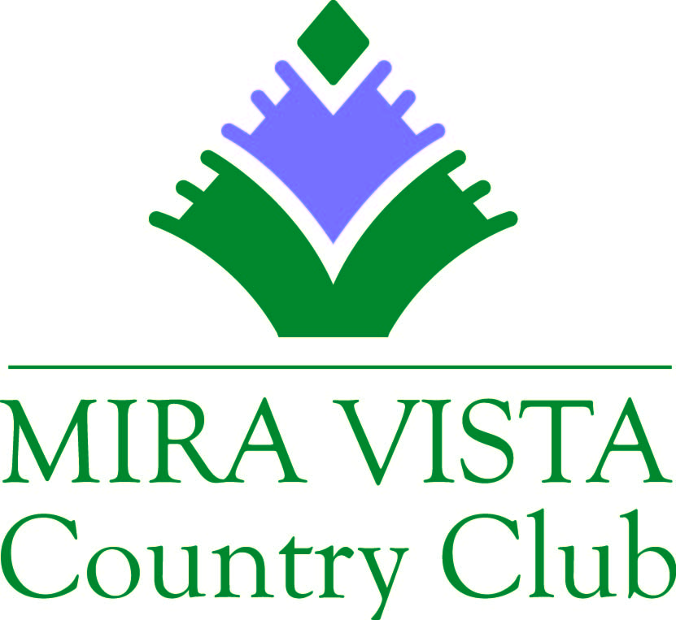

Mira Vista Country Club, a privately owned country club located in southwest Fort Worth, is looking for a qualified person to fill a full-time Line Cook position.

JOB SUMMARY: The line cook is responsible for the quick and accurate production of all items on our menu. Line cooks are required to know all of our recipes and menu items, and must be able to consistently assemble dishes that meet our standards of quality. This position works closely with the entire team to monitor food quality and production. They must be able to help in other areas in the kitchen.
Job Specifications:
Maintain a clean and organized work station.
Excellent knowledge of all food recipes and presentations.
Recognize improper presentations and be able to fix them quickly.
Be able to time and keep track of multiple orders at once.
Understand and practice all food storage procedures.
Maintain open communication with grill person and line runner.
Create great working relationships with teammates.
Qualifications:
Have a general knowledge of all kitchen equipment, including safety and proper cleaning procedures.
Receive direction from management.
Pay close attention to details.
Multi-task well and excel in a fast-paced environment.
Must be able to effectively communicate with management and co-workers.
Requirements:
Basic Serve Safe knowledge is required.
Understand and practice proper knife usage and storage.
Able to receive deliveries and verify accuracy.

Employment applications and resumes can be emailed to bgavirio@miravistacountryclub.com or faxed to (817) 294-6622.

